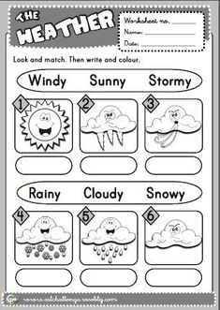

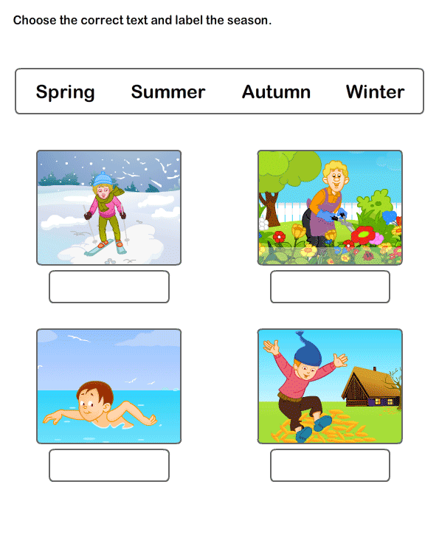Name :_______________________________

Q: Which season you like the most and why?

Ans:________________________________________________________________________________________________________________________________________________________